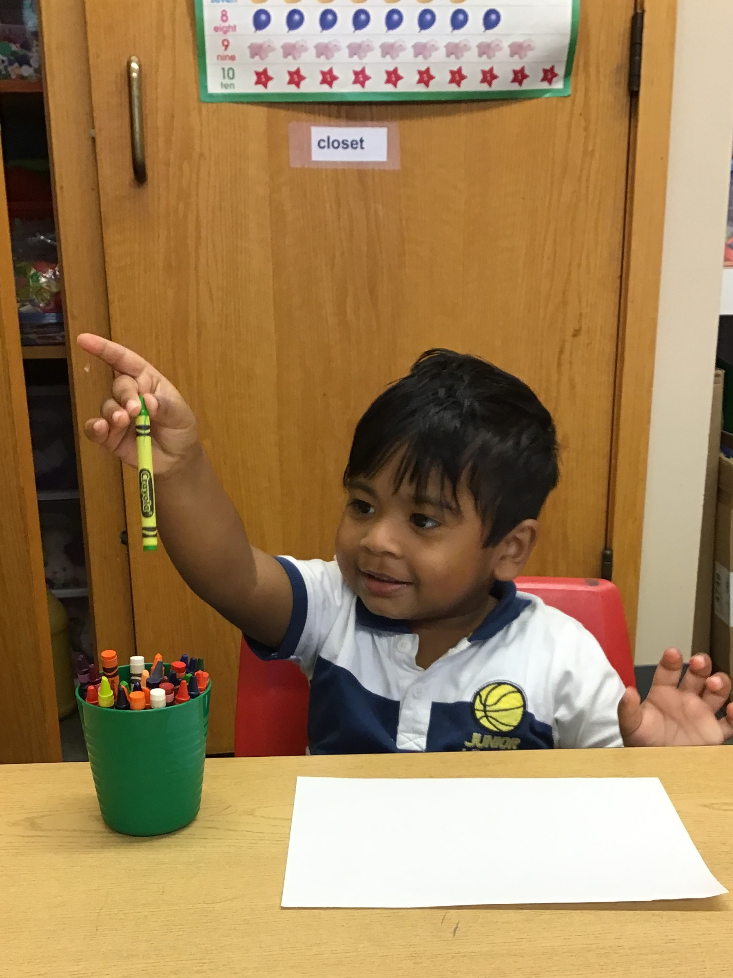  Program Goals  - Provide opportunities to experience Christian love for God, His creation and others.  - Provide a developmentally appropriate child-centered approach to preschool education.  - Develop fine and gross motor skills, and foster the development of listening and verbal skills.  - Encourage independence, creativity, self-expression and self-control.  - Learn to accept and follow directions and assume responsibilities.  - Learn basic safety rules and good health practices.  - Support families in their efforts to help their children develop as healthy, thoughtful, responsible and spiritual individuals. | Programs Offered A $70 non-refundable enrollment fee, as well as Sept. tuition for your child’s program, is due at time of enrollment. 50% of Sept. tuition is refundable through May 15, after which no refunds are issued.  Annual tuition is divided into 9 equal payments. May tuition is due on the first day of school. The remaining payments are due on the first class session of each month, Oct. – April.  3 year old program T/TH 2.75 hours 9:00 -11:45am $185/month annual tuition $1,665  4 year old program M/W/F 4 hours 9:00 am-1:00pm, $350/month annual tuition $3,150  Young 5’s program M-TH 4.25 hours 9:15am- 1:30pm, $415/month annual tuition $3,735  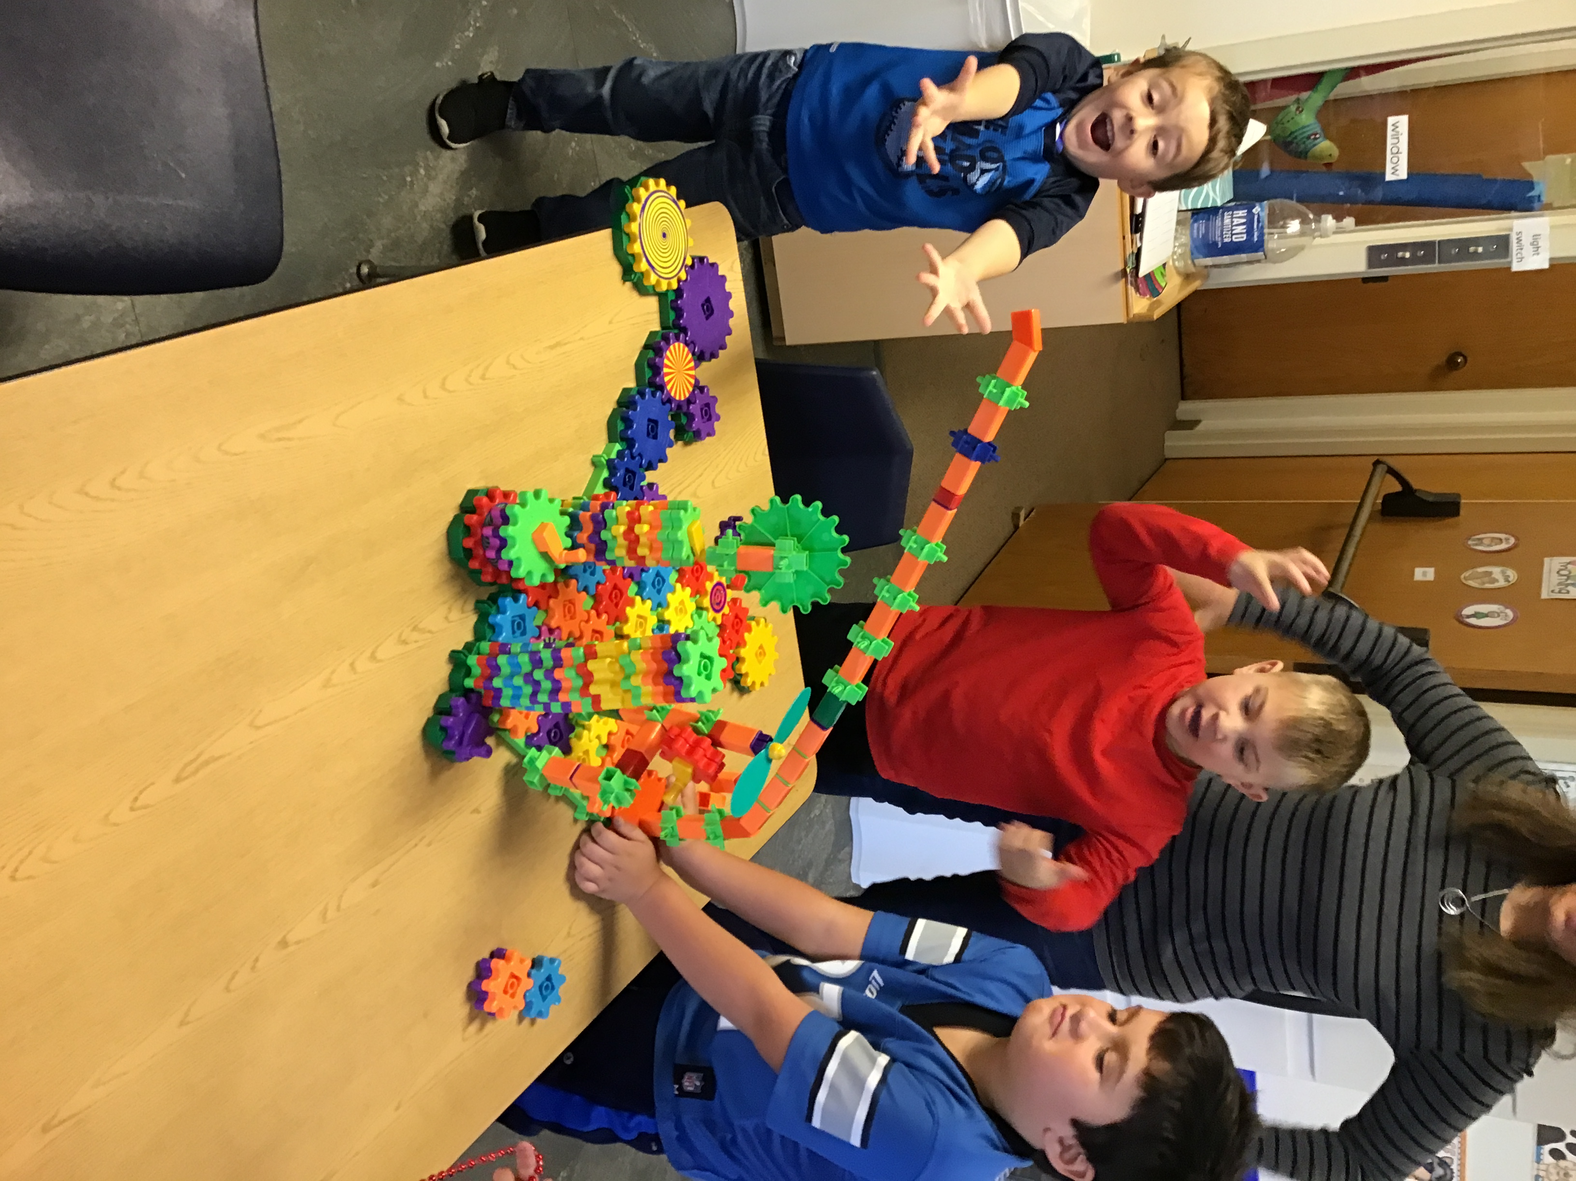 | 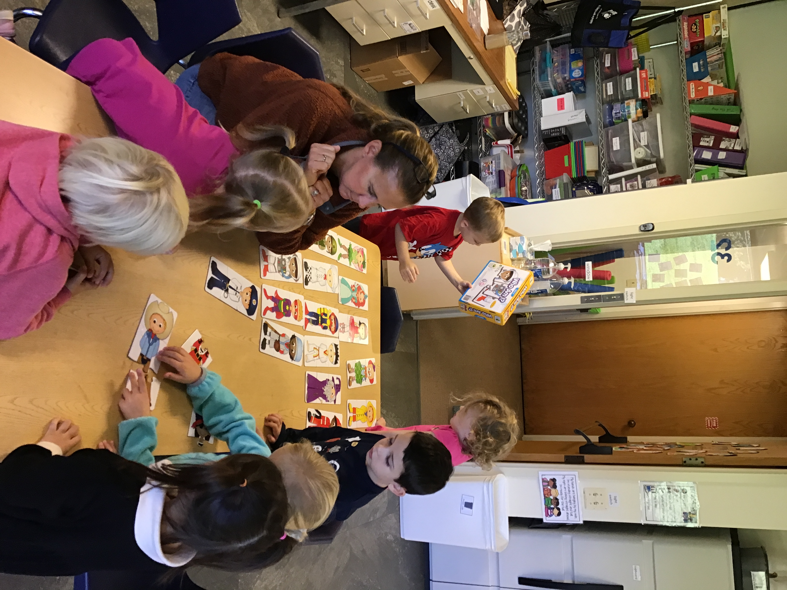  Program Descriptions  3’s Program: Children must be 3 years old by Dec. 1, 2024. Ratios are 1 teacher for every 6-7 children. Team teaching maximizes learning and growth opportunities in a shared space environment. 4’s Program: Children must be 4 years old by Dec. 1, 2024. Ratios are 1 teacher for every 8-9 children. Team teaching maximizes learning and growth opportunities in a shared space environment. 5’s Program: Children must be 5 years old by Dec. 1, 2024. Ratios are 1 teacher and 1 aide for approximately 18 children. This is a self-contained classroom focused on Kindergarten readiness skills with an integrated play-based component.

