To enroll your child, please complete the following and return it with a $70 non-refundable enrollment fee and first month’s tuition for your child’s program.  Child’s name:__________________________  Name to be called at school:  _________________________________________  Gender: ______________________________  DOB:___________________________________  Allergies:_______________________________  Parent Names:_________________________  Address:________________________________  Phone #’s:_______________________________  Emails:____________________________________________________________________________  _Class Choices:  ___Tues/Thur 3’s 9:00-11:45 am $185  ___M/W/F 4’s 9:00 am -1:00 pm $350  ___Mon-Thur 5’s 9:15am -1:30pm $415  I have read and agree to the terms of enrollment as stated.  Parent Signature:_________________________________ | Who We Are  Forest Hills Presbyterian Preschool (FHPP) has been serving families for 40 years. The preschool is Christian based and is quality rated through Great Start to Quality, Michigan’s rating platform which insures a quality early childhood program by mandating a set of standards based on current research in the field. FHPP also utilizes National Association for the Education of Young Children (NAEYC) best practices and guidelines.  Mission Statement:  Our mission is to provide an atmosphere that allows children to experience God’s love by nurturing the social, emotional, physical, intellectual and spiritual growth of each child.  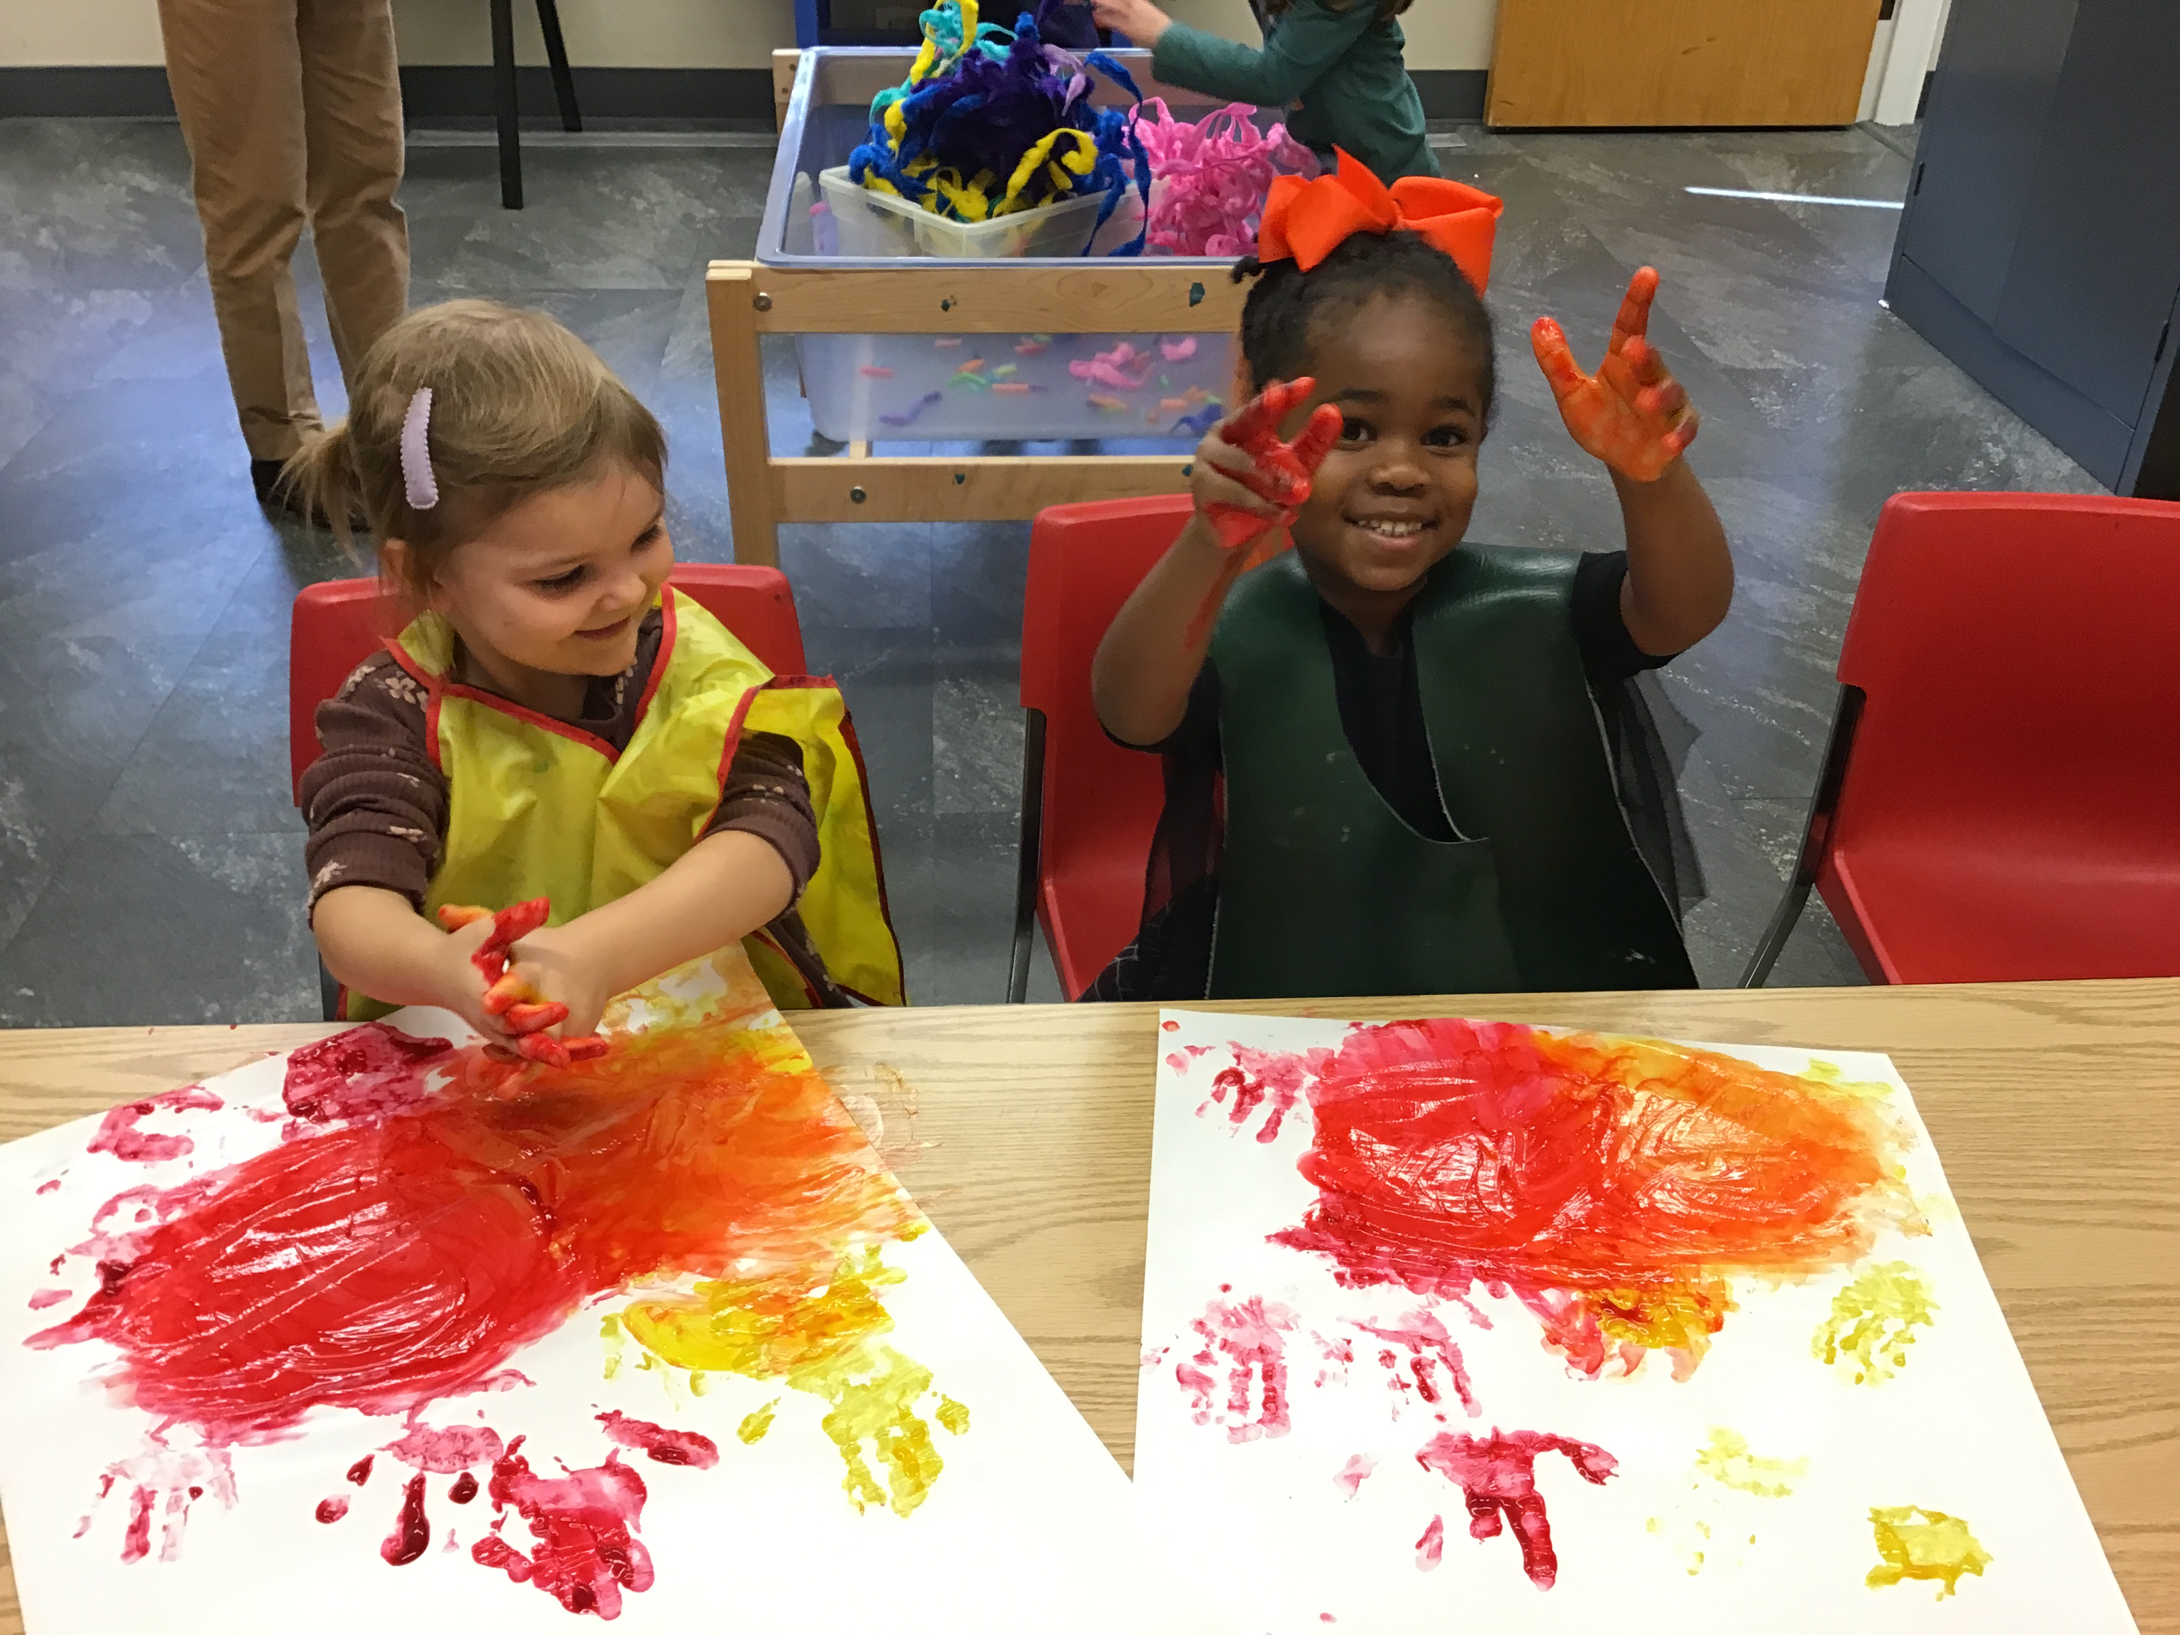 | Forest Hills  Presbyterian  Preschool  7495 Cascade Road  Grand Rapids, Mi 49546  616-957-3239  Preschool@fhpcusa.org  www.fhpcusa.org  2024-2025 school year  “Christ Centered,  Child Focused,  Love Driven.”

